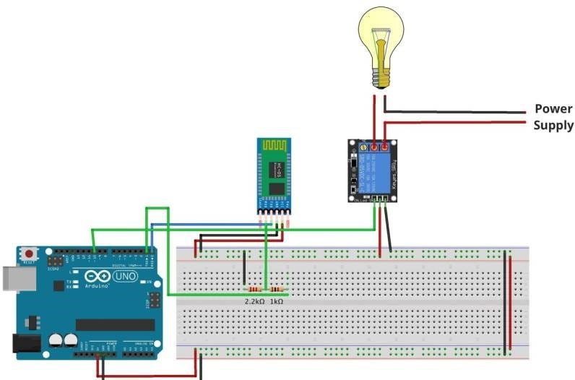CIRCUIT DIAGRAM: